**Software Requirements Specification**

**for**

**WAREHOUSE MANAGEMENT TOOL**

**Prepared by :**

<TEAM C2>

<GRP MEMBER 1>

<GRP MEMBER 1>

<GRP MEMBER 1>

<GRP MEMBER 1>

<GRP MEMBER 1>

<GRP MEMBER 1>

**Table of Contents**

1.0 INTRODUCTION 5

1.1 VISION 5

1.2 TARGET AUDIENCE 5

1.3 PROJECT SCOPE 5

2.0 OVERALL DESCRIPTION 6

2.1 PRODUCT PERSPECTIVE 6

2.2 PRODUCT FEATURES 6

2.3 SYSTEM INTERFACES 6

2.4 OPERATING ENVIRONMENT 6

3.0 SOFTWARE SPECIFIC REQUIREMENTS 7

3.1 DESCRIPTION 7

3.2 SOFTWARE INTERFACES 8

3.2.1 LOGIN FEATURES 8

3.2.2 WM TOOL FEATURES 9

4.0 PROJECT PLAN FOR INCEPTION, ELABORATION, AND CONSTRUCTION PHASE 13

4.1 PROJECT SCHEDULE 14

4.2 RISK ANALYSIS AND COUNTERMEASURES 15

4.3 INCEPTION, ELABORATION, CONSTRUCTION PHASES 16

INCEPTION PHASE 16

ELABORATION PHASE 16

CONSTRUCTION PHASE 16

5.0 GROUP STRUCTURE, ROLES, AND DESIGN ARTEFACTS 18

APPENDIX A 29

FORMAL MEETING RECORD 29

INCEPTION PHASE – ITERATION 1 30

MEETING #1 – 2 JANUARY 2018 30

Summary 30

Agenda 30

Report 30

ELABORATION PHASE – ITERATION 1 31

MEETING #2 – 2 JANUARY 2018 31

Summary 31

Agenda 31

Report 31

ELABORATION PHASE – ITERATION 2 32

MEETING #3 – 2 JANUARY 2018 32

Summary 32

Agenda 32

Report 32

Appendix B 33

WORK DIARIES 33

TEAM MEMBER 1 : <INSERT NAME> 34

TEAM MEMBER 2 : <INSERT NAME> 35

TEAM MEMBER 3 : <INSERT NAME> 36

TEAM MEMBER 4 : <INSERT NAME> 37

TEAM MEMBER 5 : <INSERT NAME> 38

TEAM MEMBER 6 : <INSERT NAME> 39

Appendix C 40

EVIDENCE OF USING VCS 40

MEMBERS 41

COMMITS 41

PULL REQUESTS 42

## 1.0 INTRODUCTION

### 1.1 VISION

This document provides an overall description of the Warehouse Management Tool, the intended audience, and design constraints that comes with developing this product. It also describes the functionality of the product as well as its non-functional requirements, and other possible factors necessary to understand the domain of the software system that we are to develop.

### 1.2 TARGET AUDIENCE

Managers from warehouse / inventory-related industry.

### 1.3 PROJECT SCOPE

This Warehouse Management Tool will serve to managers controlling the warehouse inventory. Managers are able to interact with the system with a valid account, and it is provided with the basic features that all users would have access to, such as: modifying stocks amounts, searching for stocks, and viewing summary reports.

The system flow starts from stocks assignment and stocks modifications, to stock summary reviews.

In order to better manage the functions that the systems provide, the Warehouse Management tool is divided into several subsystems:

* Security System encrypt and decrypt manager’s password registered with the Warehouse Management Tool.
* Modification of Stocks System manages any adding, removing and editing of stocks information that are being modified by managers.
* Search System manages query by managers
* Report Summary System generates summary reports based on number of ingoing and outgoing stocks

## 2.0 OVERALL DESCRIPTION

### 2.1 PRODUCT PERSPECTIVE

Warehouse Management (WM) Tool gives a better understanding of day-to-day operation with its summary information of how a warehouse is performing. Aside from this feature, managers can also modify the stocks in anyhow they deemed fit. The managers could also use this data for making critical management decisions.

#### 2.2 PRODUCT FEATURES

Warehouse Management tool has several features for users to navigate:

* Security System is able to encrypt and decrypt manager’s password registered with the Warehouse Management Tool.
* Modification of Stocks System manages any adding, removing and editing of stocks information that are being modified by managers.
* Search System manages query by managers
* Report Summary System generates summary reports based on number of ingoing and outgoing stocks

#### 2.3 SYSTEM INTERFACES

Our Warehouse Management Tool is developed as a desktop application that runs through localhost to provide stocks modifications related services.

Users can log in into the system from the PC . Our system provides basic services such as login, and search, as well as stocks modifications related services, like adding stocks, removing stocks, modifying stocks, and generating summary reports.

#### 2.4 OPERATING ENVIRONMENT

Windows 10

Mac OS

Ubuntu

## 3.0 SOFTWARE SPECIFIC REQUIREMENTS

#### 3.1 DESCRIPTION

The main purpose of WM Tool is to allow users to add/remove/modify stocks with the ability to search through all the stock records and to generate summary reports.

WM Tool provides basic functionality accessible through the following basic functions:

* Add stock : Adds each stock to the records.
* Remove stock : Remove stock form the records.
* Modify stock : Modify the details from the records.
* Search stock : Search stock from the records.:
* View summary reports : Daily,Weekly and Monthly reports of inventory movements and total sales are recorded.

All functionalities included based on the business needs of a WM Tool, to allow more convenient way of viewing stocks inventory in a glance through summary reports.

#### 3.2 SOFTWARE INTERFACES

##### 3.2.1 LOGIN FEATURES

|  |
| --- |
| **3.2.1.1 Login Function** |
| Requirement Type: **Functional** |
| PRIORITY: **High** |
| **DESCRIPTION:**   * User will login using their registered username and password. |

|  |
| --- |
| **3.2.1.2 Password Encryption** |
| Requirement Type: **Functional** |
| PRIORITY: **High** |
| **DESCRIPTION:**   * System will first encrypt the password and see if it matches the password stored at Managers.txt * If it matches, managers will be directed to WM tool menu page. * Else, it will prompt him to enter user’s login details again. |

##### 3.2.2 WM TOOL FEATURES

|  |
| --- |
| **3.2.2.1 WM TOOL INTERFACE** |
| Requirement Type: **Functional** |
| PRIORITY: **High** |
| **DESCRIPTION:**   * WM Tool will display a series of functions :   ***Add new stock***  ***Remove stock***  ***Edit stock item***  ***Search stock item***  ***Daily stock summary report***  ***Weekly stock summary report***  ***Monthly stock summary report***  ***Yearly stock summary report***  ***Quit*** |

|  |
| --- |
| **3.2.1.2 Add Stock** |
| Requirement Type: **Functional** |
| PRIORITY: **High** |
| **DESCRIPTION:**  Allow user to add a new stock item to the record. The user will be prompt for the following:   * Stock ID * Stock name |

|  |
| --- |
| **3.2.1.3 Remove Stock** |
| Requirement Type: **Functional** |
| PRIORITY: **High** |
| **DESCRIPTION:**  Allow user to remove existing stock item from the record. The user will be prompt for the following:   * Stock ID * Stock name |

|  |
| --- |
| **3.2.1.4 Edit Stock** |
| Requirement Type: **Functional** |
| PRIORITY: **High** |
| **DESCRIPTION:**  Allow user to modify existing stock item from the record. The user will be prompt for the following:   * Stock ID * Stock name   User will then be redirected to another submenu that allows user to modify their desired category. |

|  |
| --- |
| **3.2.1.5 Search Stock** |
| Requirement Type: **Functional** |
| PRIORITY: **High** |
| **DESCRIPTION:**  Allow user to search and sort existing stock item from the record. The user will be prompt for the following:   * Stock ID * Stock name * Stock Category |

|  |
| --- |
| **3.2.1.6 Stock Summary Report** |
| Requirement Type: **Functional** |
| PRIORITY: **High** |
| **DESCRIPTION:**  Allow user to view the summary report from the record. The user will be asked for the following options:   * A) Daily * B) Weekly * C) Monthly * D) Yearly |

|  |
| --- |
| **3.2.1.7 Quit** |
| Requirement Type: **Functional** |
| PRIORITY: **High** |
| **DESCRIPTION:**  Allow user to quit the whole system. |

**3. CONSTRAINTS**

The system should strictly be implemented using c++.

# 4.0 PROJECT PLAN FOR INCEPTION, ELABORATION, AND CONSTRUCTION PHASE

## 4.1 PROJECT SCHEDULE

**<GANT CHART HERE>**

|  |  |  |  |  |  |
| --- | --- | --- | --- | --- | --- |
|  | **Impact Type** | **Risk Seriousness (%)** | **Likelihood of Occurrence (%)** | **WBS**  **(affected work / task )** | **Risk Description** |
| 1 | Delay in productivity | 100% | 100% | * | Schedule Inconsistency and Miscommunication |
| 2 | Delay in productivity | 100% | 100% | * | Library support implementation |
| 3 |  | **. . .** | **. . .** | **. . .** | **. . .** |
| 4 |  |  |  |  |  |

|  |  |  |  |
| --- | --- | --- | --- |
|  | **Risk Description** | **Proposed Mgmt Plan** | **(Possible) Reduction in Risk Seriousness (%)** |
| 1 | Schedule Inconsistency and Miscommunication | Plan 1 : Meet every week to discuss current status and to clear any doubts/thoughts on project. | -50% |
| Plan 2 : Meet and have a major revamp to current goals/plans. | -25% |
| 2 | Library support implementation | Plan 1 : Needs to dedicate more time to research on it’s own Library Support for programming software. | **. . .** |
| 3 | **. . .** | **. . .** | **. . .** |

## 4.2 RISK ANALYSIS AND COUNTERMEASURES

## 4.3 INCEPTION, ELABORATION, CONSTRUCTION PHASES

## INCEPTION PHASE

This phase is the planning phase, where the business case is established, scope of the project is determined through the Software Requirement Specification(SRS). A detailed plan for the whole project is also produced in order to determine the tasks required to achieve the desired goal of the project.

The outcome of the inception phase includes:

* A Complete Business Case
* Initial phase of diagrams: Use case, Class Diagram, Component Diagram, Activity diagram.
* A Complete Risks and Countermeasures
* A Complete Project Plan of Inception, Elaboration, and Construction Phase

## ELABORATION PHASE

In this phase, we will revise our current plans and will also revise our existing diagrams to cater for construction phase.

The diagrams for elaboration phase should include:

* Class Diagram
* Activity Diagram
* Use Case Diagram
* Component Diagram

## CONSTRUCTION PHASE

This is the implementation phase where majority of the coding is being implemented to the system according to requirements from inception phase and designs from the elaboration phase.

The outcome of the construction phase will be a complete executable program.

META REPORT

# 5.0 GROUP STRUCTURE, ROLES, AND DESIGN ARTEFACTS

|  |  |  |  |
| --- | --- | --- | --- |
| **Team Number : C2** | | | |
|  | **Student Number** | **Name** | **Email Address** |
| 1 |  | (Team Leader) | Tel :    Email : |
| 2 |  |  |  |
| 3 |  |  |  |
| 4 |  |  |  |
| 5 |  |  |  |
| 6 |  |  |  |
|  |  |  |  |

**5.1 GROUP STRUCTURE**

**5.2 ROLES AND REPSONSIBLILTIES**

|  |  |  |  |
| --- | --- | --- | --- |
| **Team Number : C2** | | | |
|  | **Student Name** | **Role** | **Artefacts** |
| 1 | Minton | Manager | … |
| 2 |  |  |  |
| 3 |  |  |  |
| 4 |  |  |  |
| 5 |  |  |  |
| 6 |  |  |  |

**5.3 DESIGN ARTEFACTS**

**Design Artefacts - Use Cases (Iteration 1)**

**<USE CASE>**

**<USE CASE TEXTUAL DESCRIPTION>**

**Design Artefacts - Use Cases (Iteration 2)**

**<USE CASE>**

**<USE CASE TEXTUAL DESCRIPTION>**

**Design Artefacts - Activity Workflows (Iteration 1)**

**<ACTIVIY WORK FLOW>**

**Design Artefacts - Activity Workflows (Iteration 2)**

**<ACTIVIY WORK FLOW>**

**Design Artefacts – Component Diagrams (Iteration 1)**

**<Component Diagrams>**

**Design Artefacts - Component Diagrams (Iteration 1)**

**<Component Diagrams>**

**Design Artefacts – Class Diagrams (Iteration 1)**

**<Class Diagrams>**

**Design Artefacts - Class Diagrams (Iteration 1)**

**<Class Diagrams>**

# APPENDIX A

# FORMAL MEETING RECORD

## INCEPTION PHASE – ITERATION 1

### MEETING #1 – 2 JANUARY 2018

### Summary

* <SUMMARY HERE>

### Agenda

* + <AGENDA HERE>

### Report

**Urgent Items**

There were no urgent items to report in this meeting as this is the first meeting we held.

**Non-urgent Items and Other Reports**

There were no non-urgent items or other reports to report in this meeting as this is the first meeting we held.

## ELABORATION PHASE – ITERATION 1

### MEETING #2 – 2 JANUARY 2018

### Summary

* <SUMMARY HERE>

### Agenda

* + <AGENDA HERE>

### Report

**Urgent Items**

There were no urgent items to report in this meeting as this is the first meeting we held.

**Non-urgent Items and Other Reports**

There were no non-urgent items or other reports to report in this meeting as this is the first meeting we held.

]

## ELABORATION PHASE – ITERATION 2

### MEETING #3 – 2 JANUARY 2018

### Summary

* <SUMMARY HERE>

### Agenda

* + <AGENDA HERE>

### Report

**Urgent Items**

There were no urgent items to report in this meeting as this is the first meeting we held.

**Non-urgent Items and Other Reports**

There were no non-urgent items or other reports to report in this meeting as this is the first meeting we held.

# Appendix B

# WORK DIARIES

## TEAM MEMBER 1 : <INSERT NAME>

**INCEPTION PHASE – ITERATION 1**

**< INSERT WORK DIARIES >**

**ELABORATION PHASE – ITERATION 1**

**< INSERT WORK DIARIES >**

**ELABORATION PHASE – ITERATION 2**

**< INSERT WORK DIARIES >**

## TEAM MEMBER 2 : <INSERT NAME>

**INCEPTION PHASE – ITERATION 1**

**< INSERT WORK DIARIES >**

**ELABORATION PHASE – ITERATION 1**

**< INSERT WORK DIARIES >**

**ELABORATION PHASE – ITERATION 2**

**< INSERT WORK DIARIES >**

## TEAM MEMBER 3 : <INSERT NAME>

**INCEPTION PHASE – ITERATION 1**

**< INSERT WORK DIARIES >**

**ELABORATION PHASE – ITERATION 1**

**< INSERT WORK DIARIES >**

**ELABORATION PHASE – ITERATION 2**

**< INSERT WORK DIARIES >**

## TEAM MEMBER 4 : <INSERT NAME>

**INCEPTION PHASE – ITERATION 1**

**< INSERT WORK DIARIES >**

**ELABORATION PHASE – ITERATION 1**

**< INSERT WORK DIARIES >**

**ELABORATION PHASE – ITERATION 2**

**< INSERT WORK DIARIES >**

## TEAM MEMBER 5 : <INSERT NAME>

**INCEPTION PHASE – ITERATION 1**

**< INSERT WORK DIARIES >**

**ELABORATION PHASE – ITERATION 1**

**< INSERT WORK DIARIES >**

**ELABORATION PHASE – ITERATION 2**

**< INSERT WORK DIARIES >**

## TEAM MEMBER 6 : <INSERT NAME>

**INCEPTION PHASE – ITERATION 1**

**< INSERT WORK DIARIES >**

**ELABORATION PHASE – ITERATION 1**

**< INSERT WORK DIARIES >**

**ELABORATION PHASE – ITERATION 2**

**< INSERT WORK DIARIES >**

# Appendix C

# EVIDENCE OF USING VCS

**(VERSION CONTROL SOFTWARE)**

## MEMBERS

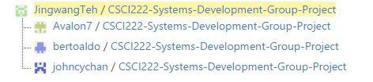

## COMMITS

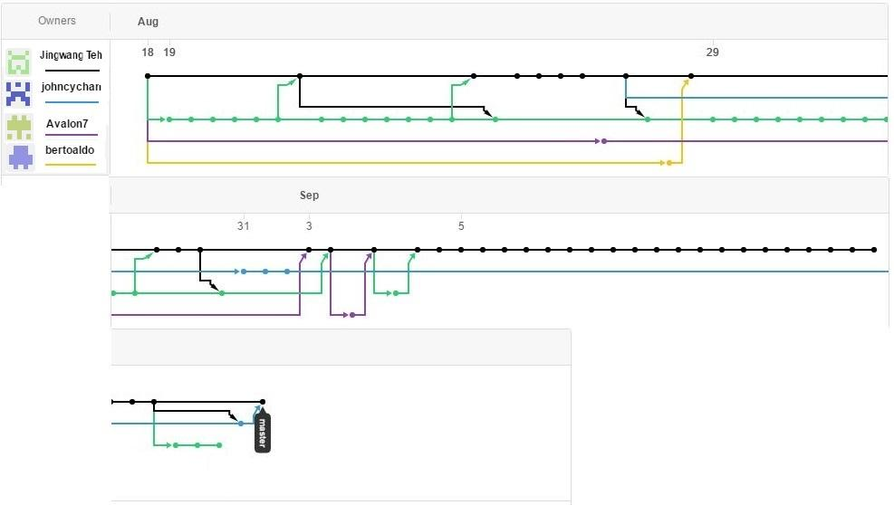

## PULL REQUESTS



